**Project 3: Behavioral Cloning**

Data Collection:

For this project, I only use the dataset provided by Udacity and does not collect additional data on my own. I find it sufficient to train the model to achieve a reasonably good driving behavior. I am using pandas module to read in the csv file.

Data Processing:

As half of the dataset has steering value as zero, I reduce the 80% of the zero steering data using the following codes.

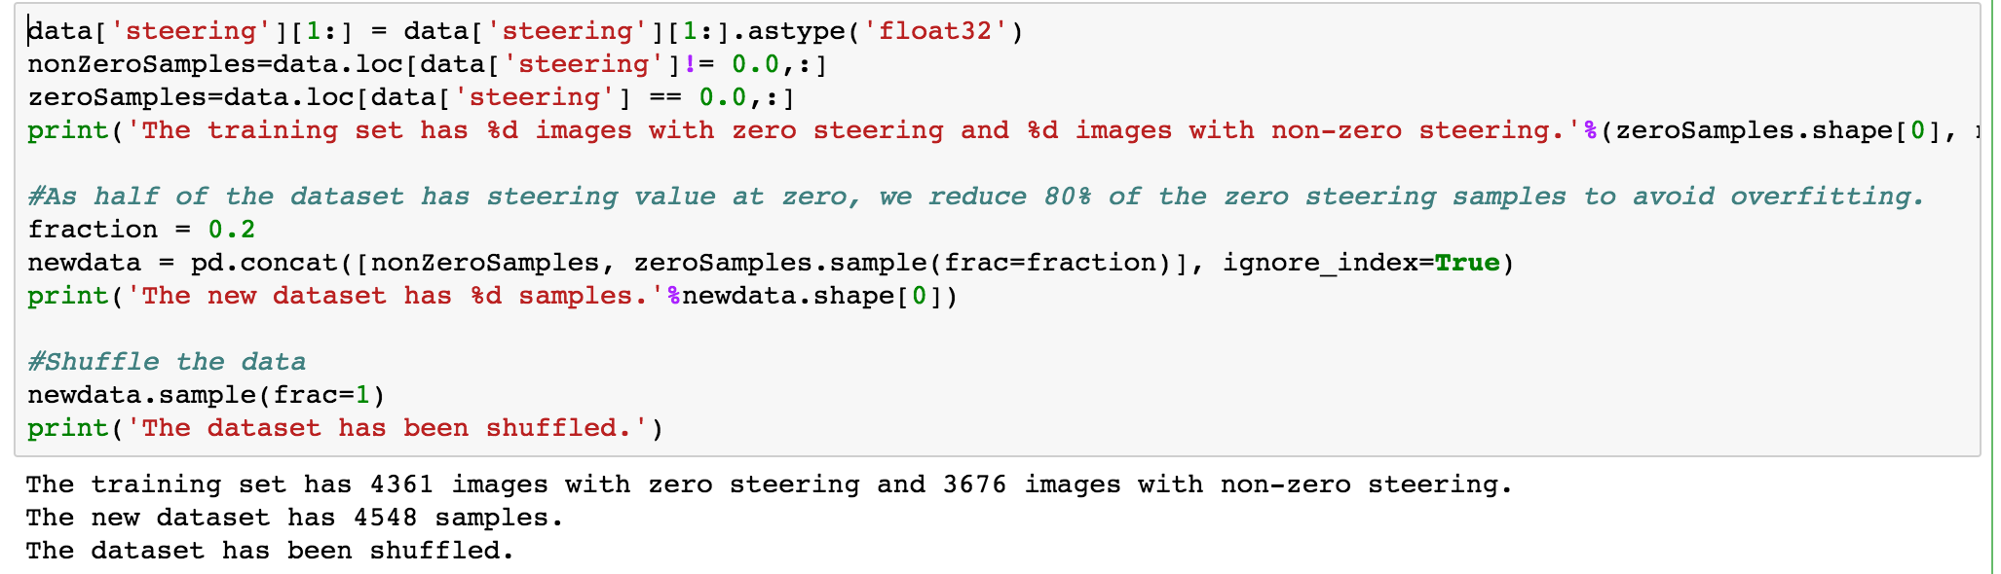

To reduce the irrelevant part of the image (sky, trees, etc.), I crop the top 60 and bottom 25 pixels from the original images and resize the image to 90*30.

To help training the car to react when driving close to the edge (recovery driving), I randomly select left/right/center cameras and adjust the steering measurement by 0.2 accordingly.

I also randomly flip the images at 50% probability to avoid the bias towards left steering.

The final distribution of steering value looks close to normal distribution.

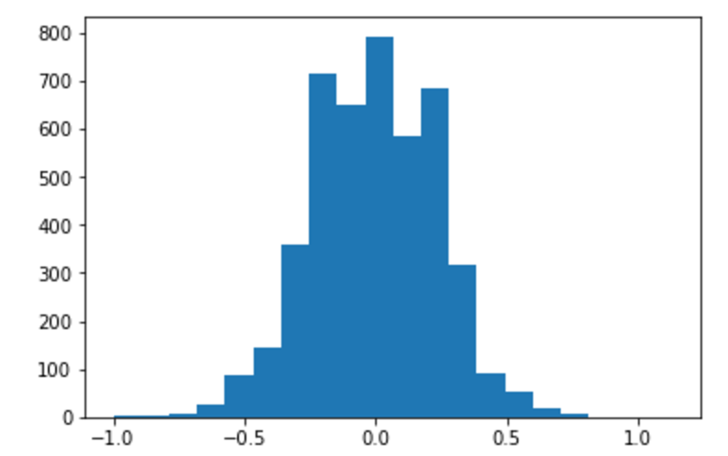

I reference the Nvidia model and build my own. I am using Adam optimizer with learning rate as 0.0001. The data is split into 80% (traing set) and 20% (validation set). The architecture details can be read as below.

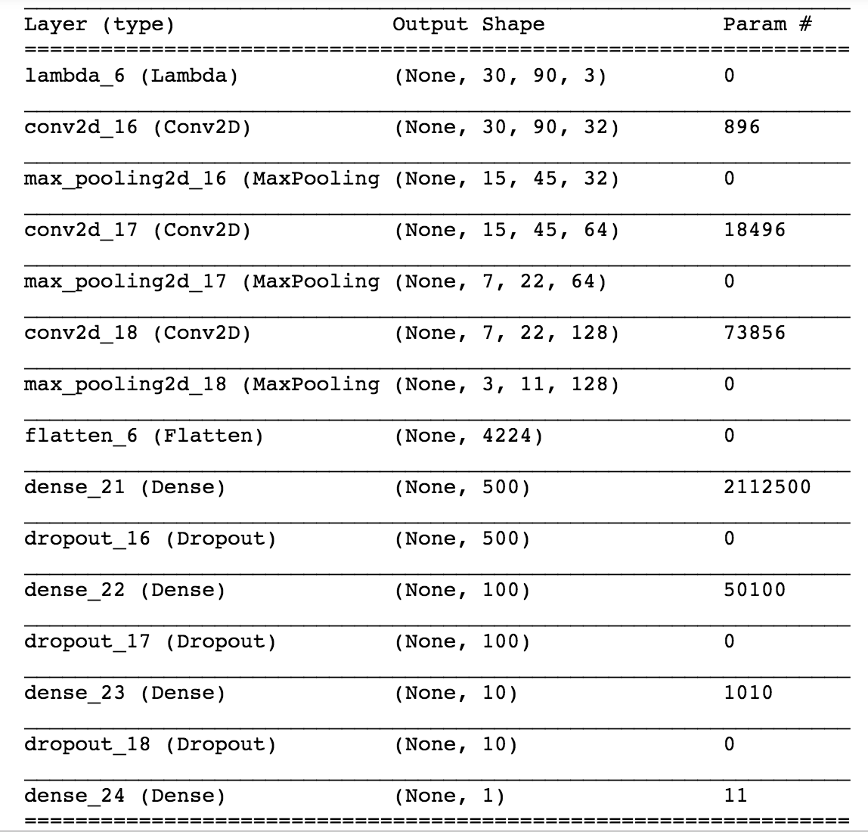

I find by 5 epochs, the loss of both training and validation sets decreases significantly but further training may incur the overfitting problem.

The driving output can be viewed in the video attached.